|  |  |  |
| --- | --- | --- |
|  | SORTING |  |
| Exp No.: 6 |  | **Name:** S Vishakan |
| Date: 23-09-2020 |  | **Reg. No:** 18 5001 196 |

**AIM:**

To write assembly language programs to perform the following experiments:

1. Ascending order sorting using Bubble Sort.
2. Descending order sorting using Bubble Sort.

**PROGRAM – 1: ASCENDING ORDER SORT:**

**ALGORITHM:**

1. Begin.
2. Declare the data segment.
3. Initialize data segment with array and its length len.
4. Close the data segment.
5. Declare the code segment.
6. Set a preferred offset (preferably 100)
7. Load the data segment content into AX register.
8. Transfer the contents of AX register to DS register.
9. Move the length len to CH register.
10. Till CH goes to zero:
    1. Load SI with offset of list.
    2. Move the length len to CL register.
    3. Till CL goes to zero:
       1. Compare values at SI and SI+1 address.
       2. If value at SI > value at SI+1, exchange them.
       3. Increment SI.
       4. Decrement CL.
    4. Decrement CH.
11. Introduce an interrupt for safe exit. (INT 21h)
12. Close the code segment.
13. End.

|  |  |
| --- | --- |
| **PROGRAM** | **COMMENTS** |
| assume cs:code, ds:data | Declare code and data segment. |
|  |  |
| data segment | Initialize data segment with values. |
| list db 05h, 04h, 03h, 02h, 01h | Stores the list of elements. |
| len db 04h | Stores the length of the above array. |
| data ends |  |
|  |  |
| code segment | Start the code segment. |
| org 0100h | Initialize an offset address. |
| start: mov ax, data | Transfer data from “data” to AX. |
| mov ds, ax | Transfer data from memory location AX to DS. |
| mov ch, len |  |
|  |  |
| outer: mov si, offset list | Pointer at first element. |
| mov cl, len | Inner loop count. |
|  |  |
| inner: mov al, [si] |  |
| mov ah, [si+1] |  |
| cmp ah, al | Compare by AL – AH. |
| jnc skip | Skip if no carry occurred on AL – AH. |
| xchg al, ah | Exchange register contents. |
| mov [si], ax | Copy back moved contents to data segment (AL -> [SI], AH -> [SI + 1]) |
|  |  |
| skip: inc si | Go to next element. |
| dec cl | Decrement inner loop count. |
| jnz inner | Restart inner loop. |
| dec ch | Decrement outer loop count. |
| jnz outer | Restart outer loop. |
|  |  |
| mov ah, 4ch |  |
| int 21h | Interrupt the process with return code and exit. |
| code ends |  |
| end start |  |

**UNASSEMBLED CODE:**

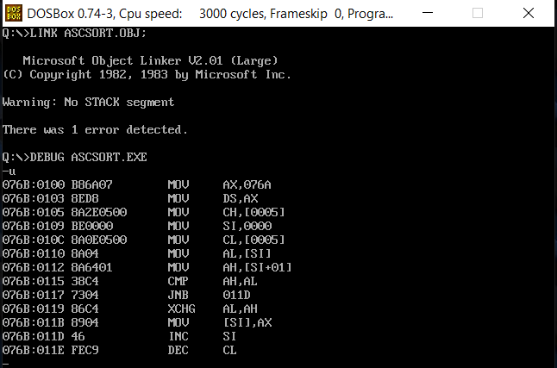

**SAMPLE I/O SNAPSHOT:**

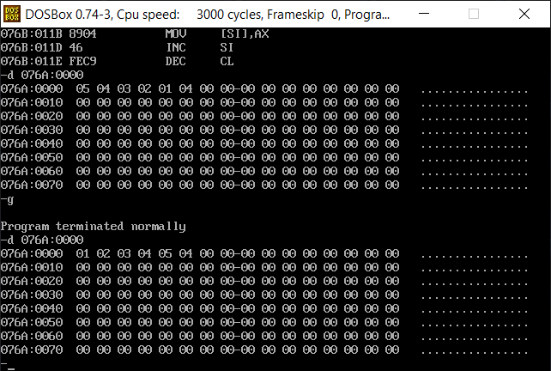

**PROGRAM – 2: DESCENDING ORDER SORT:**

**ALGORITHM:**

1. Begin.
2. Declare the data segment.
3. Initialize data segment with array and its length len.
4. Close the data segment.
5. Declare the code segment.
6. Set a preferred offset (preferably 100)
7. Load the data segment content into AX register.
8. Transfer the contents of AX register to DS register.
9. Move the length len to CH register.
10. Till CH goes to zero:
    1. Load SI with offset of list.
    2. Move the length len to CL register.
    3. Till CL goes to zero:
       1. Compare values at SI and SI+1 address.
       2. If value at SI < value at SI+1, exchange them.
       3. Increment SI.
       4. Decrement CL.
    4. Decrement CH.
11. Introduce an interrupt for safe exit. (INT 21h)
12. Close the code segment.
13. End.

|  |  |
| --- | --- |
| **PROGRAM** | **COMMENTS** |
| assume cs:code, ds:data | Declare code and data segment. |
|  |  |
| data segment | Initialize data segment with values. |
| list db 05h, 04h, 03h, 02h, 01h | Stores the list of elements. |
| len db 04h | Stores the length of the above array. |
| data ends |  |
|  |  |
| code segment | Start the code segment. |
| org 0100h | Initialize an offset address. |
| start: mov ax, data | Transfer data from “data” to AX. |
| mov ds, ax | Transfer data from memory location AX to DS. |
| mov ch, len |  |
|  |  |
| outer: mov si, offset list | Pointer at first element. |
| mov cl, len | Inner loop count. |
|  |  |
| inner: mov al, [si] |  |
| mov ah, [si+1] |  |
| cmp al, ah | Compare by AH – AL. |
| jnc skip | Skip if no carry occurred on AH – AL. |
| xchg al, ah | Exchange register contents. |
| mov [si], ax | Copy back moved contents to data segment (AL -> [SI], AH -> [SI + 1]) |
|  |  |
| skip: inc si | Go to next element. |
| dec cl | Decrement inner loop count. |
| jnz inner | Restart inner loop. |
| dec ch | Decrement outer loop count. |
| jnz outer | Restart outer loop. |
|  |  |
| mov ah, 4ch |  |
| int 21h | Interrupt the process with return code and exit. |
| code ends |  |
| end start |  |

**UNASSEMBLED CODE:**

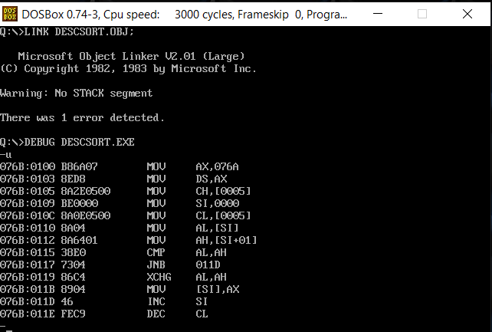

**SAMPLE I/O SNAPSHOT:**

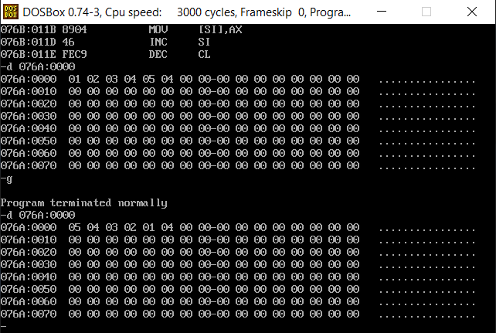

**RESULT:**

The assembly level programs were written to perform the above specified sorting functions and the output was verified.